7PAM2002-0509-2024 Data Science Project
Assignment: PDM Plan

Student Name: VASANTH KUMAR MEKALA
Student ID: 22058159
Course: MSC Data Science with Advanced Research
Module: Data Science Project
Submission Date: 19 Aug 2024

Project Overview
Project Title:
Early warning system for bankrupt prediction by using machine learning models.
Summary of Project and Background
- Bankruptcy is a financial event that can have harsh consequences for stakeholders, including creditors, regulatory institutions, employees, and investors.
- In such circumstances, bankruptcy prediction plays a significant role in supporting economic growth and maintaining financial stability.
AIM:
The Aim of bankruptcy prediction is to identify companies that are at risk of financial failure before it happens, using financial and operational data. This enables early intervention by stakeholders to mitigate losses and take corrective actions.
Research Question:
Can Machine learning models accurately predict company bankruptcy based on corporate governance indicators and the financial ratios?
Building on previous studies:
- Altman Z-score: Combines five financial ratios to estimate bankruptcy risk.
- Asif et al. (2024): Applied Altman model on NSE-listed firms.
- Zhu (2024): Advocated ML in advancing financial decision-making.
These works establish the limitations of linear models and support ML's superiority in analyzing nonlinear relationships for bankruptcy prediction.
Dataset Description:
- The Data set obtained from Kaggle, a publicly available free to use.
- It consisting of 6819 entries with 96 columns which are financial metrics like before interest and % after tax, operating gross margin, operating profit rate, tax rate, net value for share and etc.

Objectives:
- Data Preparation:
The dataset has been loaded using a pandas data frame
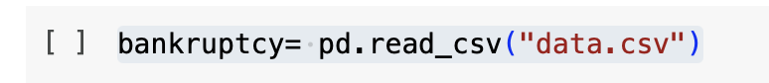
Finding Null values
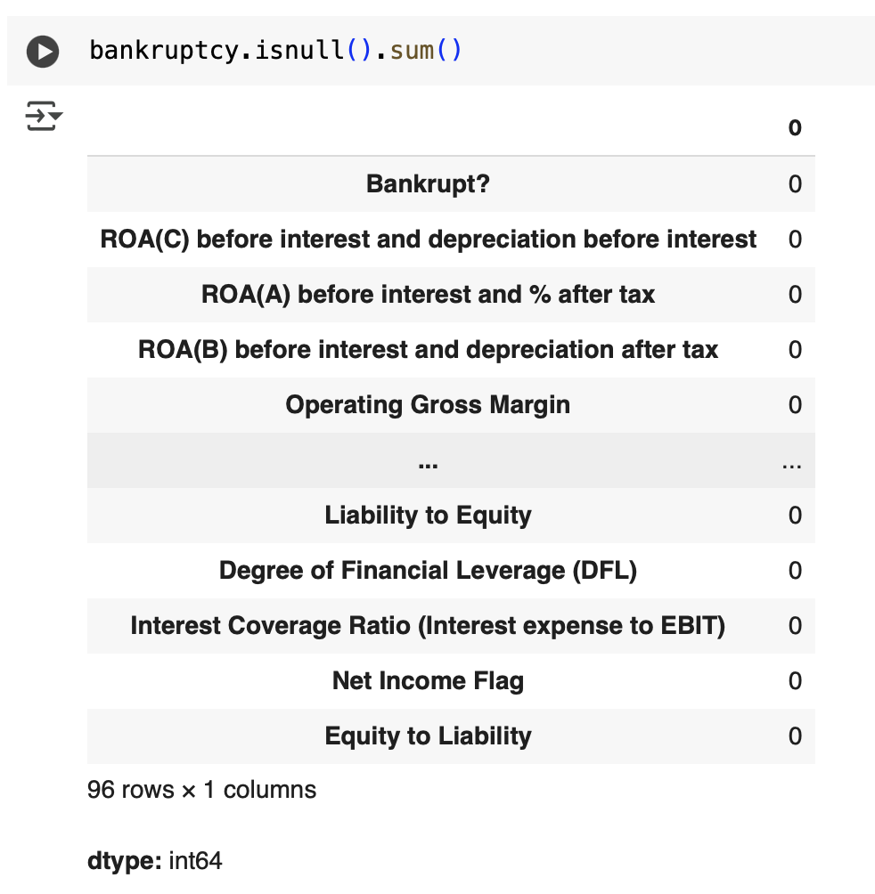
Loading Data and null value analysis

Data types have been previewed

- Exploratory data analysis:

- Scatter plot of ROA(A) before interest and % after tax vs. Total assets
- Most data points are clustered near lower total asset values, suggesting many companies in the dataset are relatively small in size.
- ROA does not appear to be a strong sole indicator of bankruptcy.

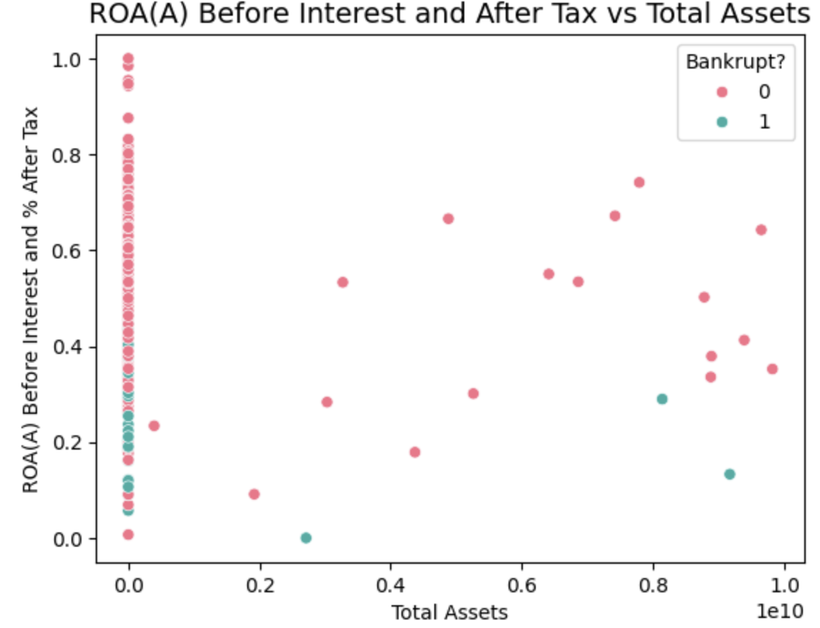

- Scatter plot of Debt Ratio % vs Total Assets
- Most companies have low debt ratios, especially those with large total assets.
- A clear indication that lower debt ratios, especially in high-asset firms, correlate with lower bankruptcy risk.

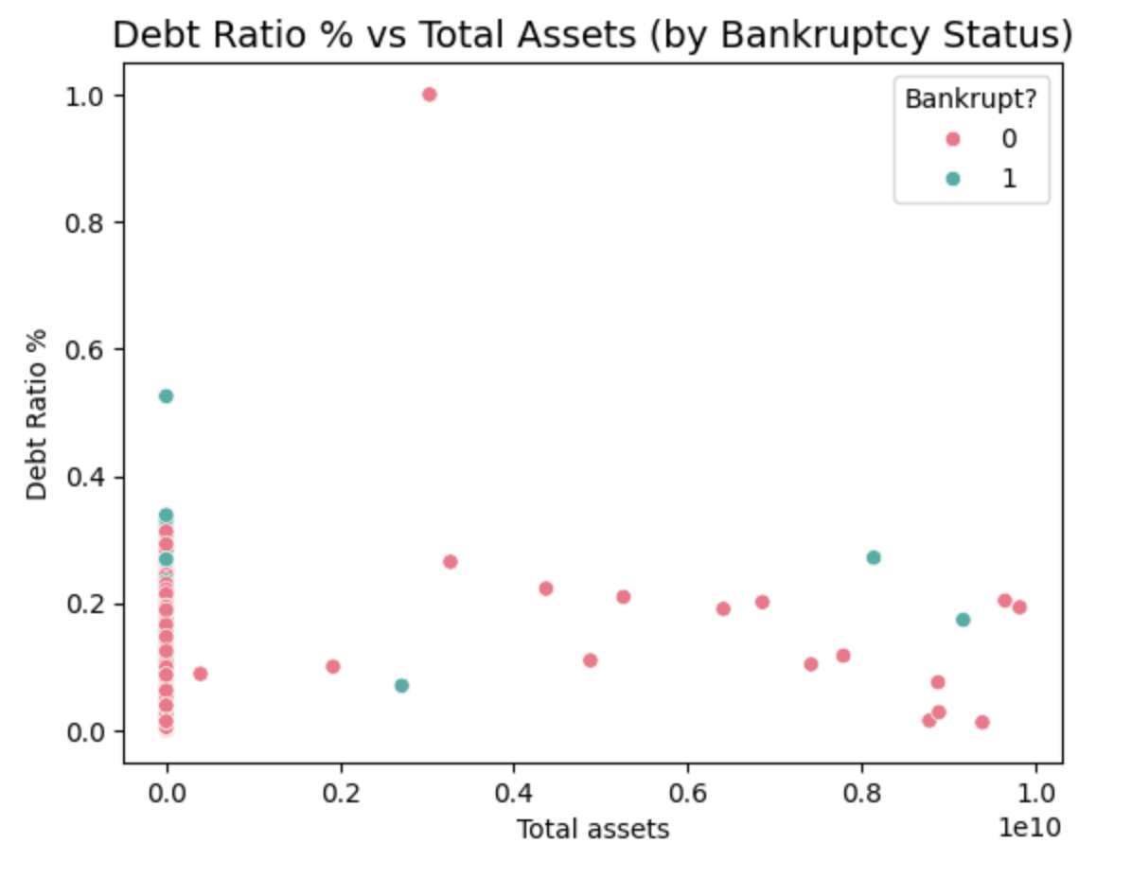

- Scatter plot of Net income to total assets vs. Total assets
- A similar clustering of companies with very small total assets exists here as well.
- This plot suggests a slightly better separation between bankrupt and non-bankrupt companies compared to the ROA and Debt ratio plot.

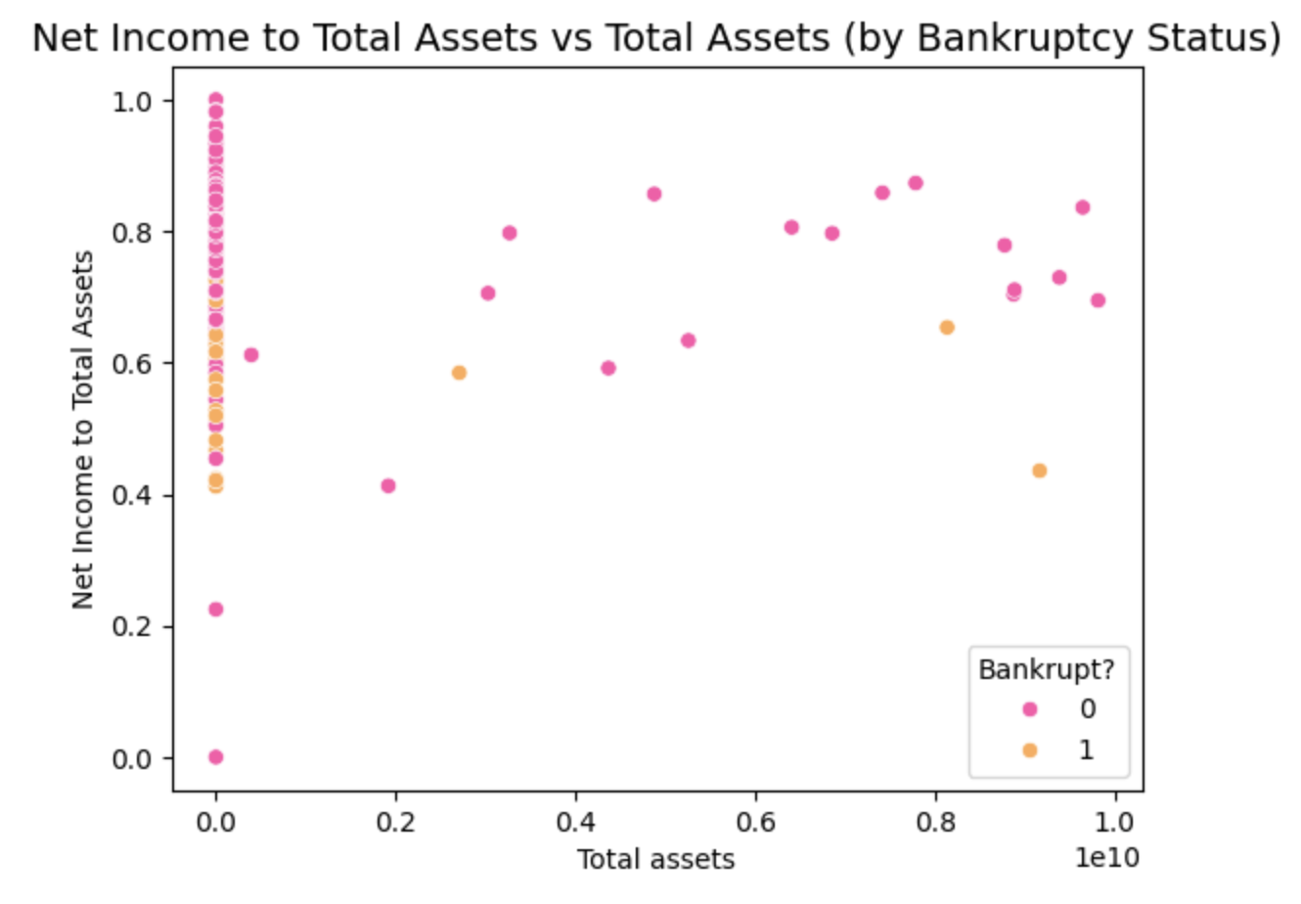

- Data Processing:

- Measuring how strongly each feature is correlated with the target variable ('Bankrupt?’).
- Finding the input features that have positive correlation
- This helps reduce irrelevant or weakly related features, which can improve model performance and reduce overfitting.
- Creating a new data frame with selected features.

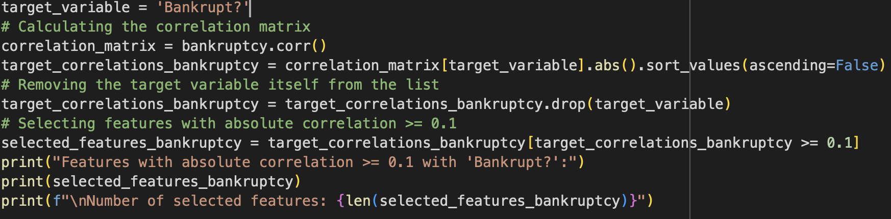

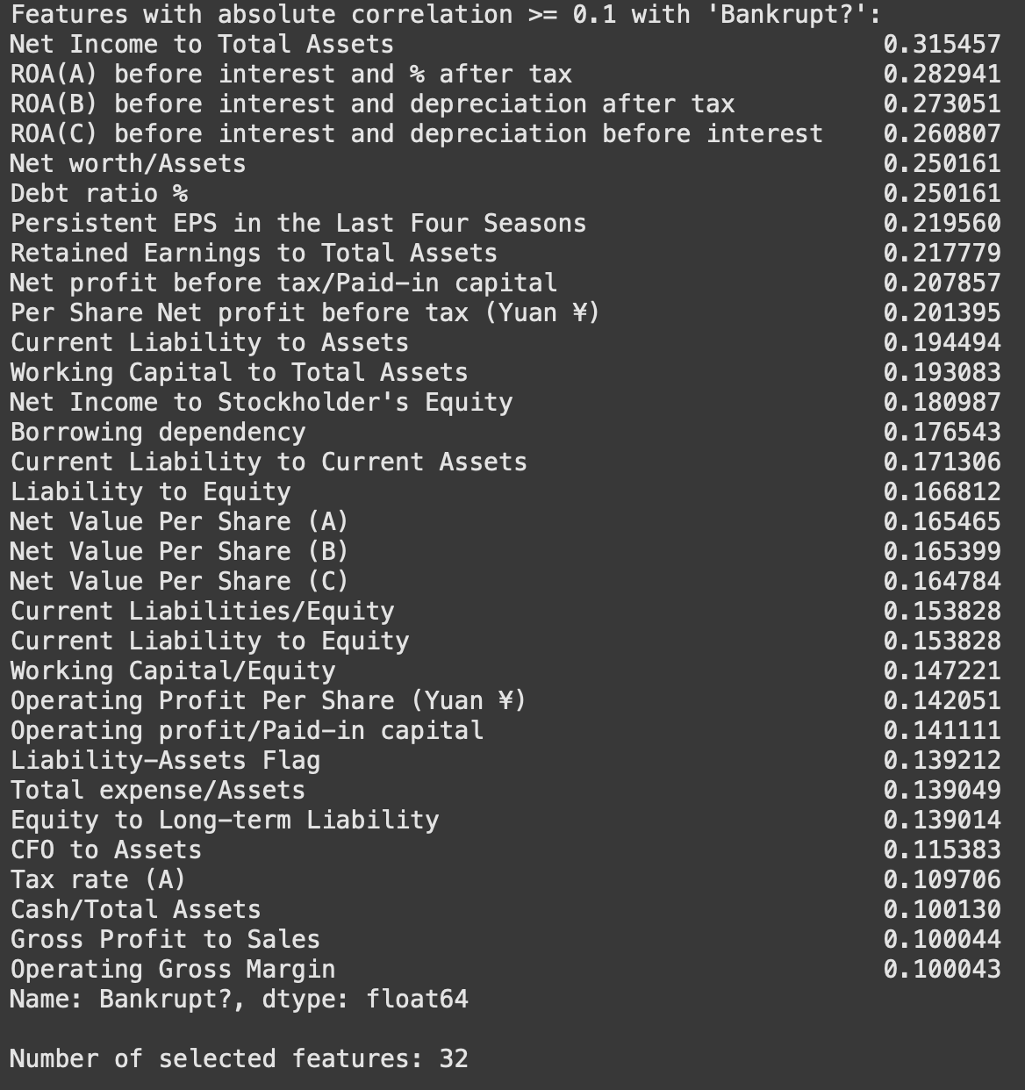
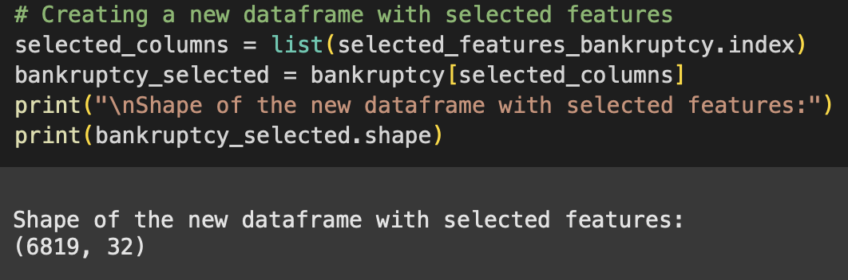
Data preprocessing

- Data Balancing:
- To address the class imbalance present in the original dataset, we applied Random Under-Sampling using the Random Under Sampler method from the imblearn library.
- This technique balances the dataset by randomly removing samples from the majority class, ensuring both classes have an equal number of observations.
- To verify the effectiveness of the down sampling, we generated a count plot using Seaborn to visualize the distribution of the target variable 'Bankrupt?' after resampling.
- The resulting bar chart clearly shows that the number of bankrupt and non-bankrupt companies is now equal, confirming that the dataset has been successfully balanced.

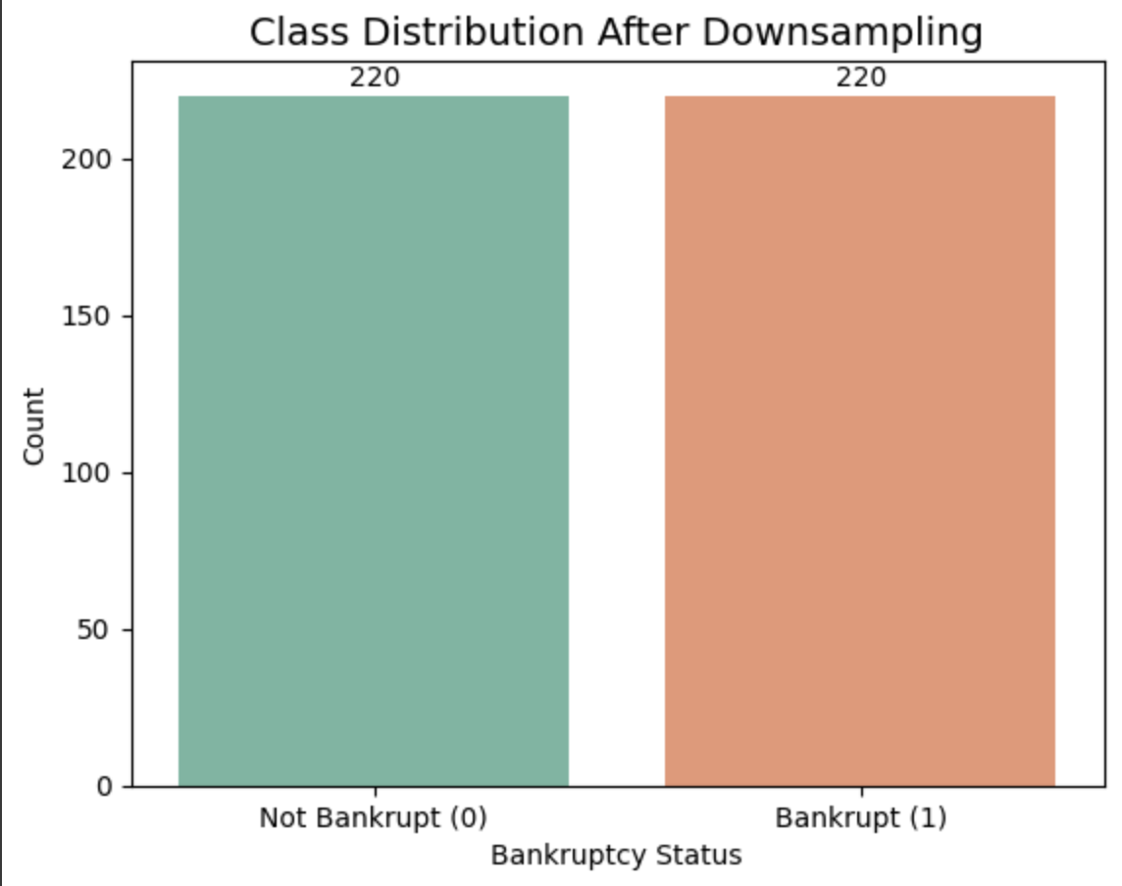

- Data Split and Model Training:
To prepare the balanced dataset for model training and evaluation, I performed a train-test split using the train, test and split function.
- 75% for training the machine learning model.
- 25% for testing the model's performance
To predict the bankruptcy status of companies, three different machine learning classification models were implemented and evaluated:
- XGBoost Classifier
- Random Forest Classifier
- Logistic Regression
Each model was trained on the down sampled training set (75% of the balanced data). Hyperparameters were tuned using default settings initially, with potential adjustments based on validation results.

Model performance was assessed using standard classification metrics such as
- Accuracy
- Precision
- Recall
- F1-score
- ROC-AUC Score

- Model Performance Analysis:

XGBoost accuracy: 0.85

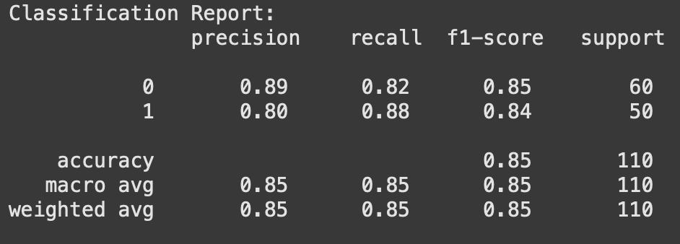

Random Forest: 0.85

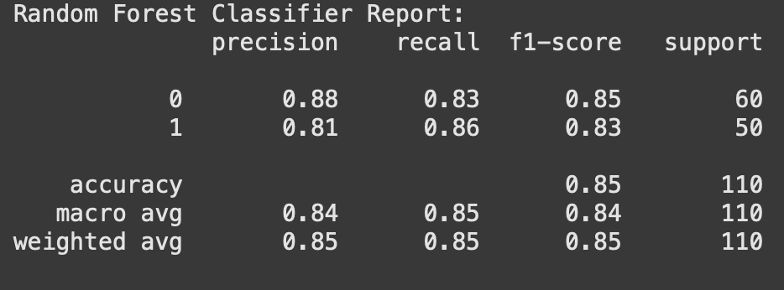

Logistic regression: 0.87

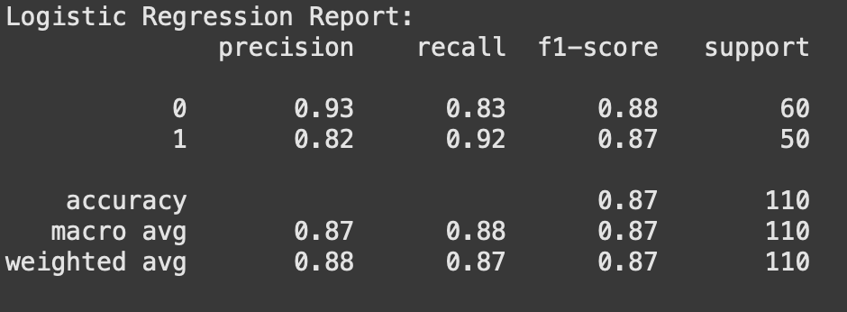

- Conclusion:

- Effective EDA and preprocessing have been performed for effective results
- Logistic regression has been the best-performing model
- References:

- Asif, M., Saxena, A., Bhardwaj, S., Tiwari, S. and Chaturvedi, S. (2024) ‘A STUDY OF ALTMAN Z-SCORE BANKRUPTCY MODEL FOR ASSESSING BANKRUPTCY RISK OF NATIONAL STOCK EXCHANGE-LISTED COMPANIES’, Proceedings on Engineering Sciences, 6(2), pp. 789–806. (Available at: https://doi.org/10.24874/PES06.02A.006.)
- Di Quirico, R. (2023) ‘Uncertainty, Anxiety and the Post-Pandemic Economic Environment’, Clinical Neuropsychiatry, 20(4), p. 227. (Available at: https://doi.org/10.36131/cnfioritieditore20230401.)
- Statista (2025) Largest U.S. bankruptcies as of June 2019, Statista. (Available at: https://www.statista.com/statistics/1096794/largest-bankruptcies-usa-by-assets/) [Accessed: 29 May 2025].
- Tierney, A. (2024) Number of business bankruptcies U.S. 2000-2020, Statista. (Available at: https://www.statista.com/statistics/817918/number-of-business-bankruptcies-in-the-united-states/) [Accessed: 29 May 2025].

Project Timeline
Task | Start Date | End Date | Duration
Project Selection | 14th May 2025 | 21st May 2025 | 1 week
Data Collection | 22nd May 2025 | 5th Jun 2025 | 2 weeks
Data Preprocessing | 6th Jun 2025 | 13th Jun 2025 | 1 week
Model Implementation | 14th Jun 2025 | 28th Jun 2025 | 2 weeks
Application of ML Techniques | 29th Jun 2025 | 13th July 2025 | 2 weeks
Model Evaluation | 14th July 2025 | 21st July 2025 | 1 week
Refinement & Optimization | 22nd July 2025 | 25th July 2025 | 3 days
Interim Assessment Preparation | 26th July 2025 | 28th July 2025 | 2 days
Final Model Testing | 29th July 2025 | 31st July 2025 | 2 days
Report Writing | 1st Aug 2025 | 14th Aug 2025 | 1.5 weeks
Final Assessment Preparation | 15th Aug 2025 | 17th Aug 2025 | 2 days
Submission | 18th Aug 2025 | 18th Aug 2025 | 1 day

Data Management Plan:
Data Overview and Meta Data:
The project uses structured financial and corporate governance data to build and evaluate machine learning models for predicting bankruptcy. The data primarily includes quantitative metrics from company financial statements, along with qualitative governance indicators.

Dataset Source: https://www.kaggle.com/datasets/fedesoriano/company-bankruptcy-prediction.

Document Control:
  - Source: Downloaded from Kaggle (Early warning system for bankrupt prediction).
  - Format: CSV file containing financial attributes.
Data Storage:
    - Local Storage: Organized in directories (e.g., data/, code/, outputs/).
    - Format: CSV or Excel files.
Data & Code Backup:
- Backup Methods: Code will be regularly backed up on GitHub, with dataset files stored on OneDrive.
README FILE:
Contents: The ReadMe file will outline the project, setup steps, dataset description, and usage instructions, including licensing and contributors.
GitHub Repository: https://github.com/Vasi0796/Vasanth-s-project-2025.git
Data Ethics:
- GDPR Compliance:
The dataset is anonymized, containing no personal or sensitive information, so GDPR requirements are not applicable.
- University of Hertfordshire Ethics Compliance:
This project complies with UH’s ethical standards, as it does not involve personal or sensitive data.
- Data Usage Permission:
The dataset is publicly available on Kaggle, explicitly approved for research purposes.
- Ethical Data Collection:
The data is hosted on Kaggle, a reputable platform, that ensures ethical standards in data gathering.

